**Create Node Red service**

|  |  |
| --- | --- |
| Team ID | PNT2022TMID19565 |
| Project Name | Smart waste management system for metropolitan cities |

Step 1: Login into IBM CLOUD account

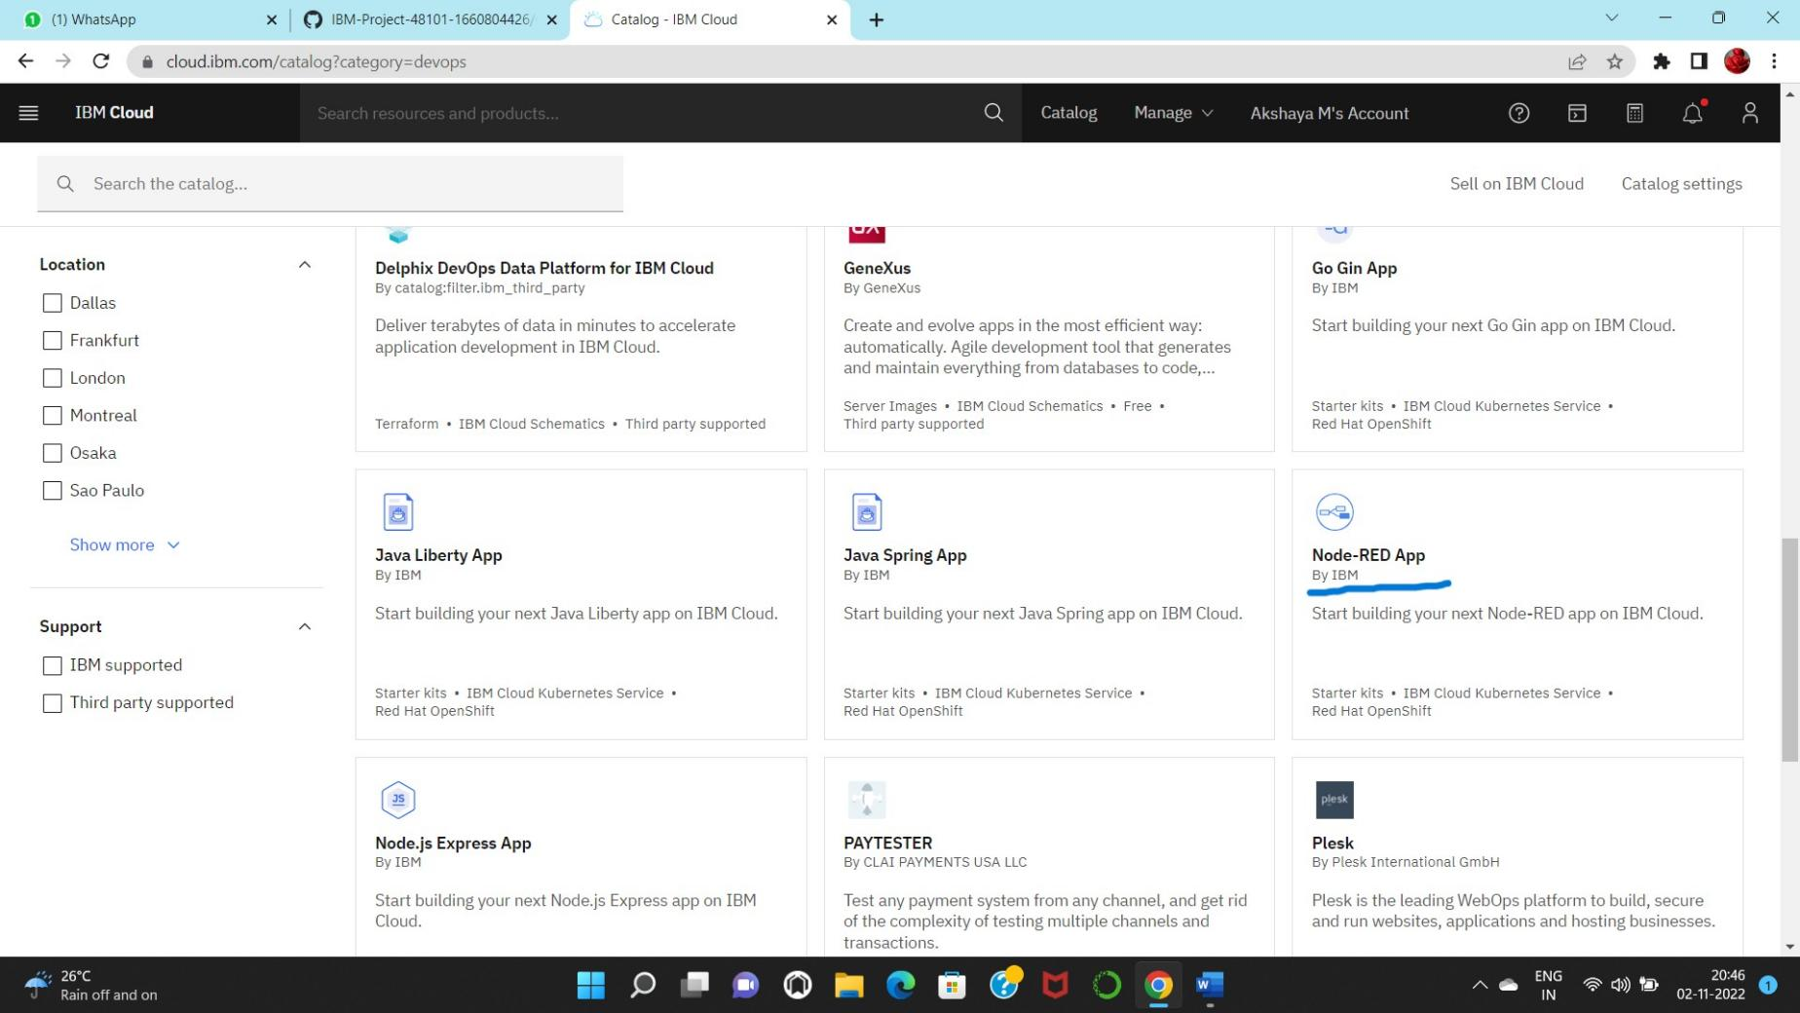

Step2: In catalog, search for node red application

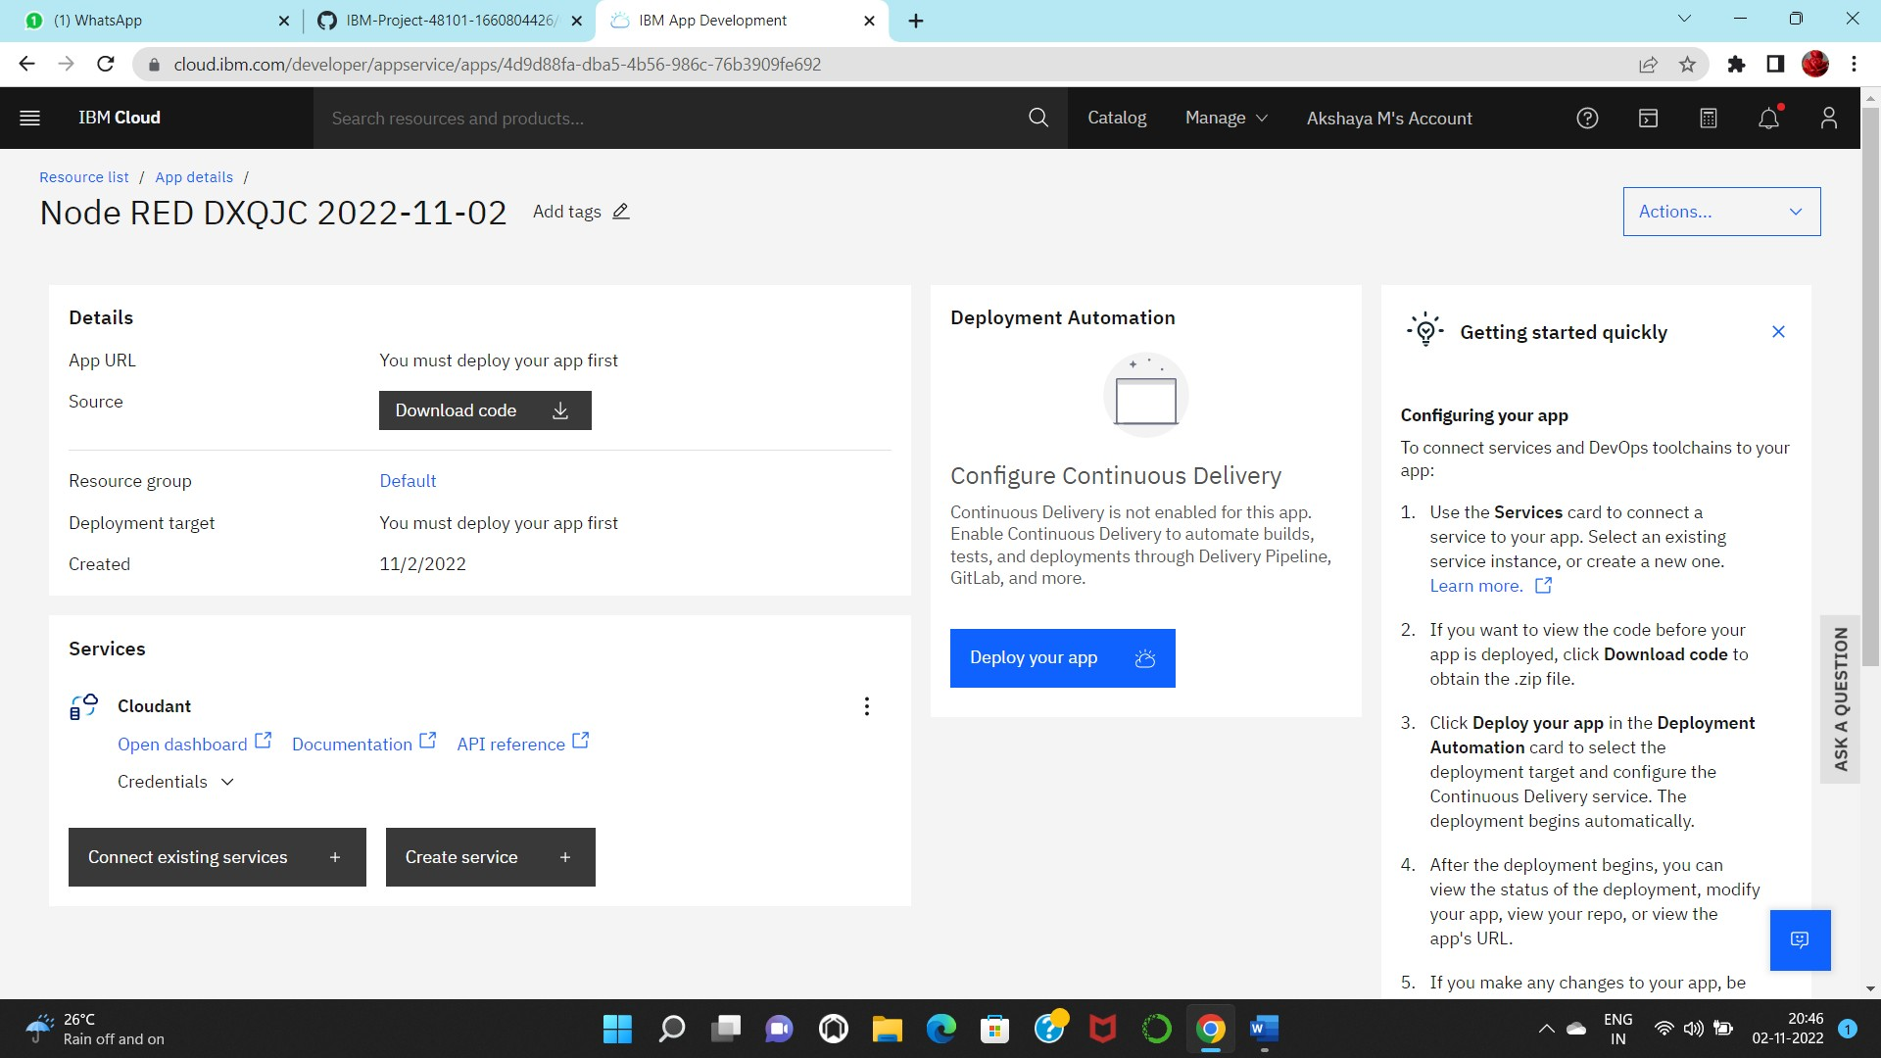

Step 3: Enter the project details and click on create Step 4: click on deploy option and deploy

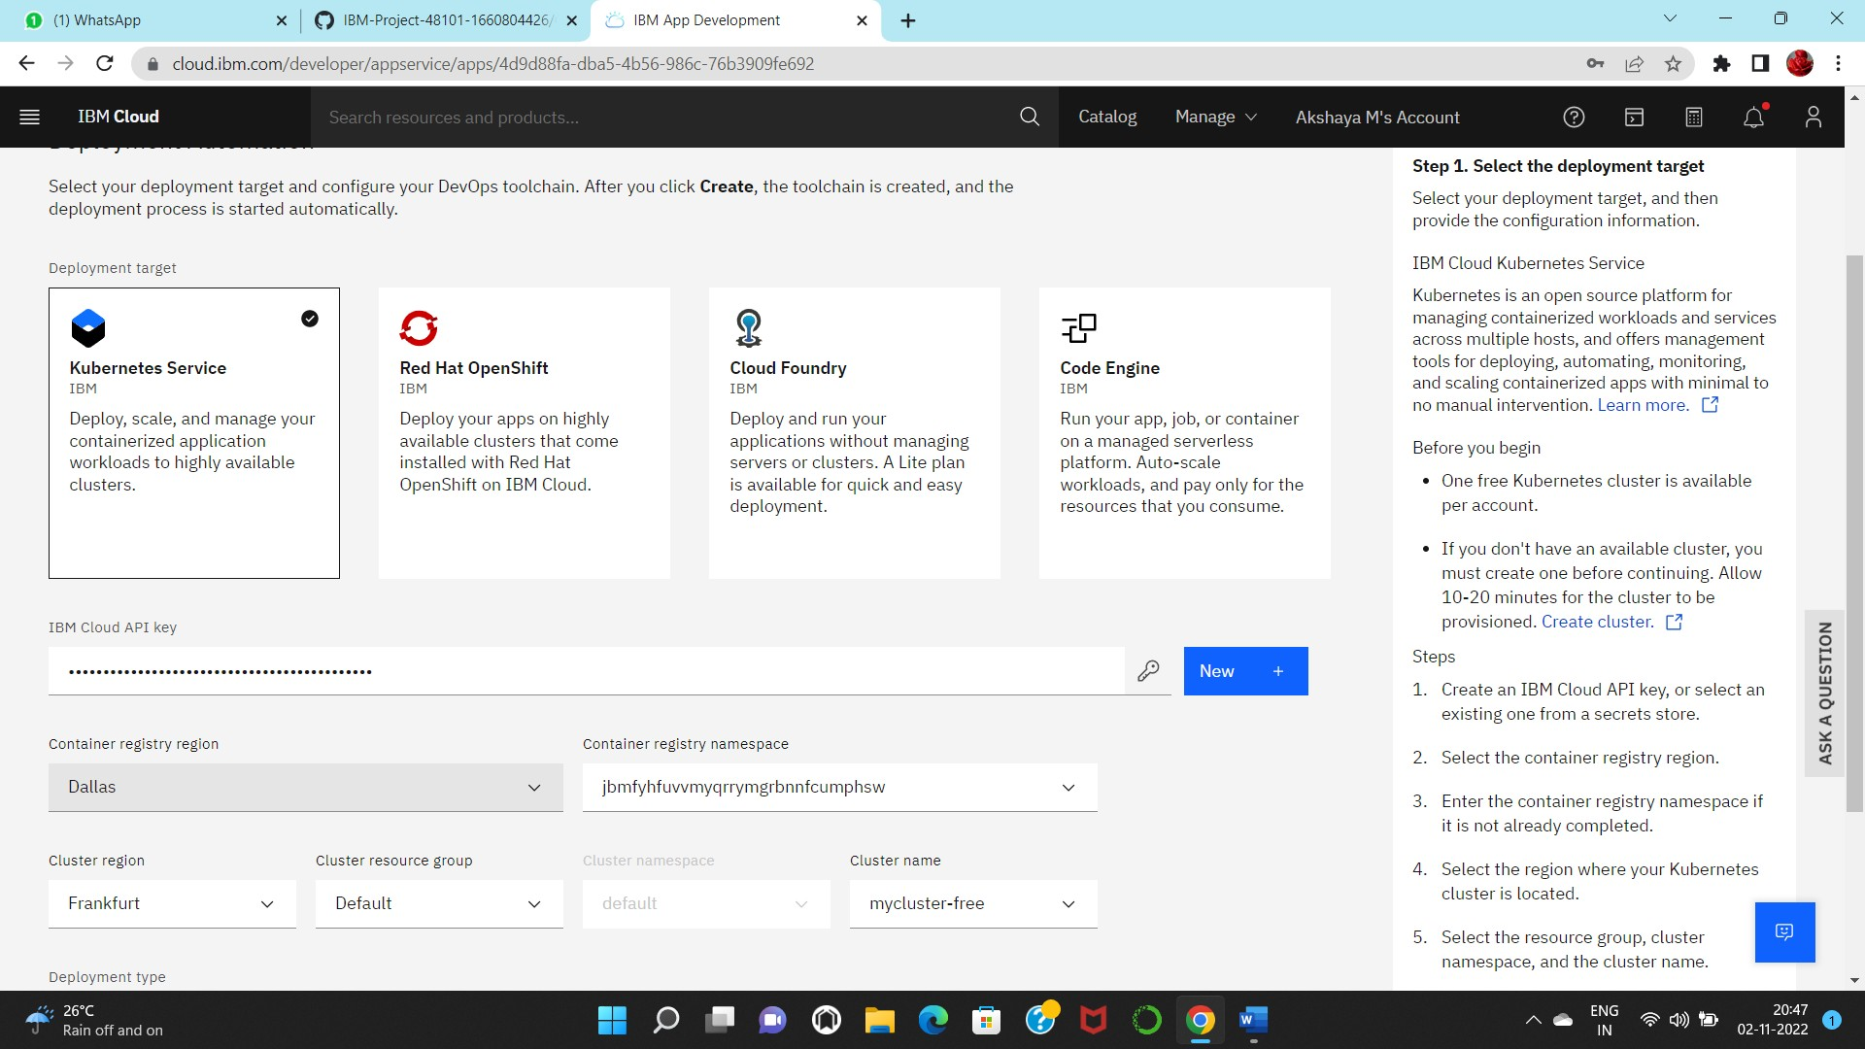

Step 5: Set up the environment for deploying and click on create

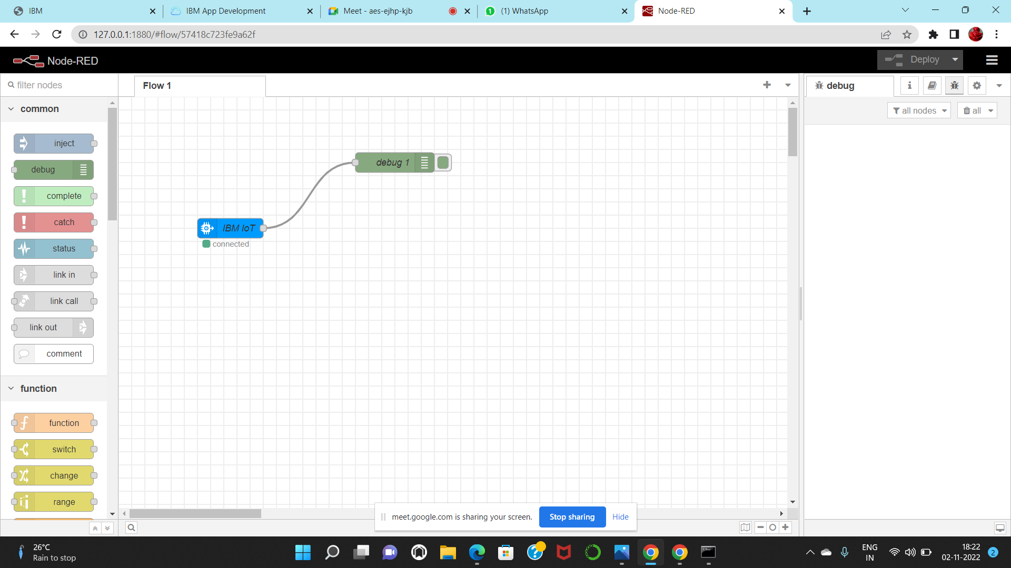

Step 6: Now drag and drop the nodes and connect nodes with IOT Watson platform

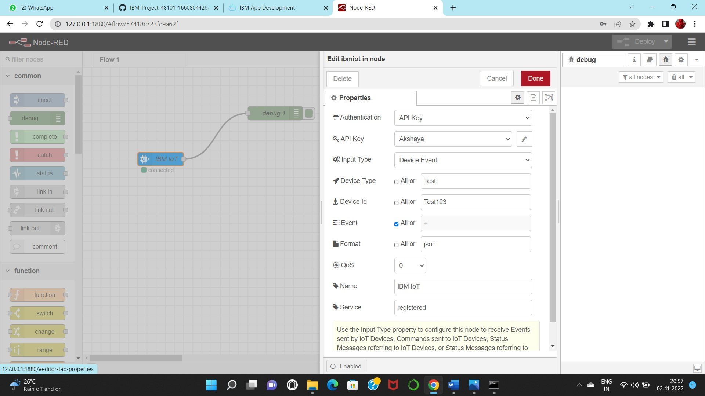

Step 7: setup the settings that connects node red service with Watson IOT

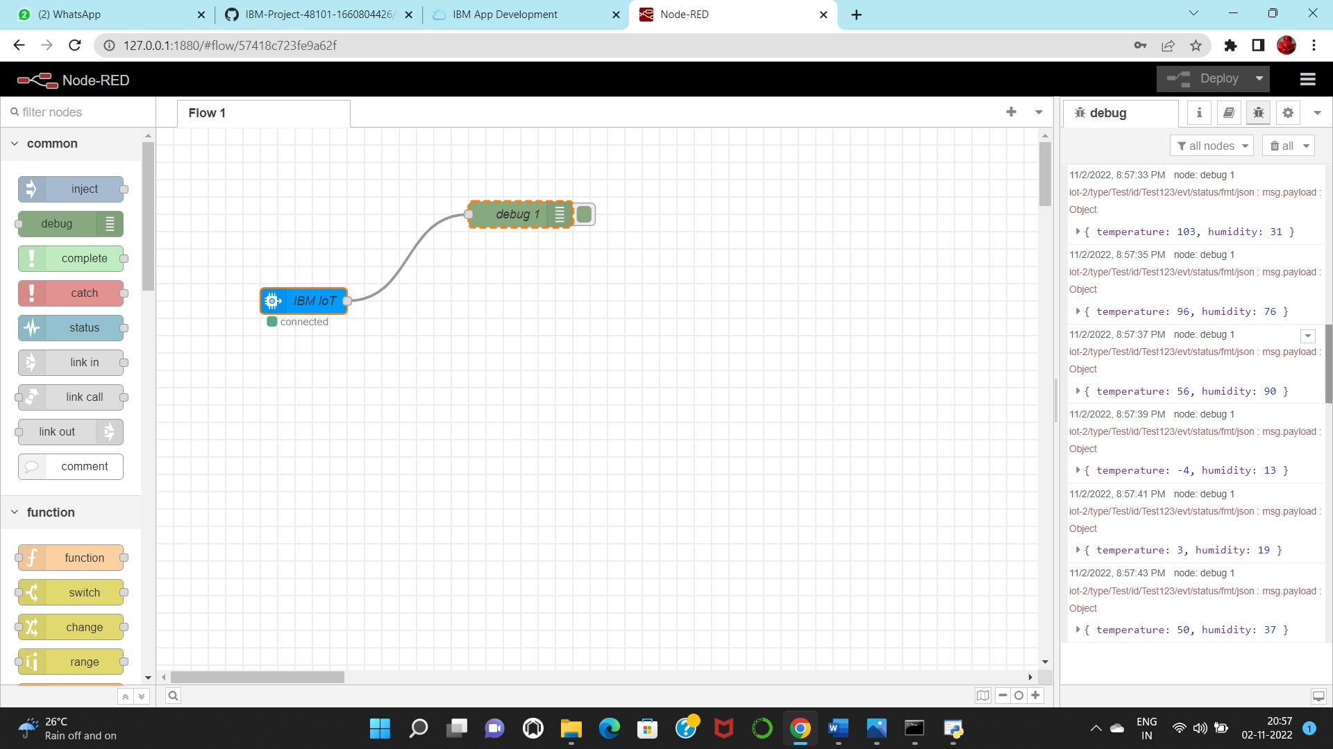

Step 8: Finally, output can be seen in node red service

